CIRCULUM VITAE
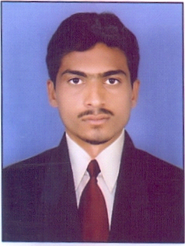

SATAMOLLA SAIKUMAR

Email Id: ramlilamydhan@gmail.com
Mobile/ Whatsapp: +91-9704460010, 8341676420

Career Objective:

Seeking a position in safety service where my extensive experience will be further developed and utilized and to ensure the safety of the company assets as well as company by identifying hazards by education and motivation company personnel and other their families to work and live safety

Educational Qualification:

- Intermediate From Vasavi Junior College In 2012
- Secondary School Certificate From J. R. M. High School In 2010
- Appearing of The Degree 3rd Year. Vasavi Degree Collage.
Strengths:

- Self Motivation and to motivate others.
- Ability to work in team

Professional Traits:

- Ability to deal with people dramatically
- Disciplined & good etiquette
- Willingness to work in team and hard worker
- Get good ideas for any questions

Computer Proficiency:

- Operating System : Microsoft Windows All Versions
- MS Office : MS Word, MS Excel, MS Power Point, Internet
- Typing : English, Telugu,

Work Experience:

- Has Worked as Housing Information Asst, INDIA from 05-April-2012 to 05-September -2013.

- December -2013 to till date: Working as Meeseva (Computer Typist) with B.Com Computer & Pvt. Ltd (Bhainsa, Telangana) INDIA

Job Responsibilities:

- Daily pap talk/toolbox meeting with workers
- Display safety posters & literature through the job site
- Group activities like housekeeping, scrap minimization
- Deliver site induction to new worker & site visitor
- Maintain safty records as per statuary requirement
- Opration and maintance of all types of portable extinguishers
- Ensuring the availability of personal protective & fire fighting equipment’s

Personal Profile:

Name : Satamolla SaiKumar
Age : 22 Years
Sex : Male
Marital Status : Single
Religion : Hindu
Date of Birth : 11-06-1995
Address : H.No.4-3-1/248, A P Nagar, Near Sri Medha School Road,
Bhainsa-504103, Dist. Nirmal (Telangana)
Language Known : English, Hindi, Marati, & Telugu

Declaration:

The above mentioned statements are true to the best of my knowledge and can be supported be relevant documents as & when required.
Date:
Place: Bhainsa
SATAMOLLA SAIKUMAR

