App_TC_07_01: To check card/ coupon type appear or not after selecting the parent account:
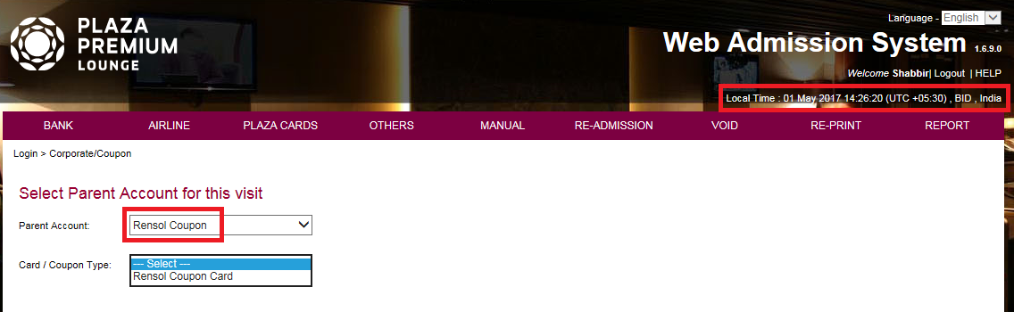
App_TC_07_02: To ensure that if we did not set any "card mask" in BOS then it should displayed full coupon no:
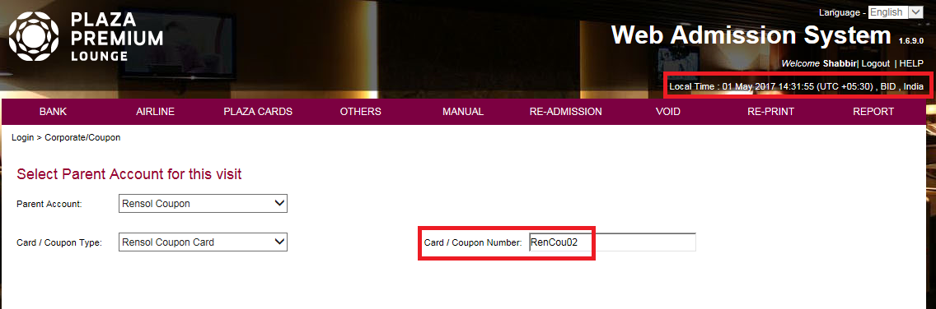
App_TC_07_03: To ensure that if we did not fill those coupon no. that we have set in "Coupon Import/Export" screen of BOS then on click of "Continue" button it should displayed proper validation message:
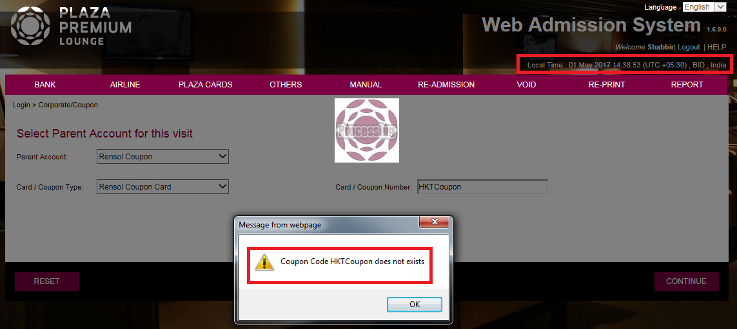
App_TC_07_04: To fill coupon no. manually according to start series that we have set in BOS, and proceed:
After click on ‘Continue’ button:
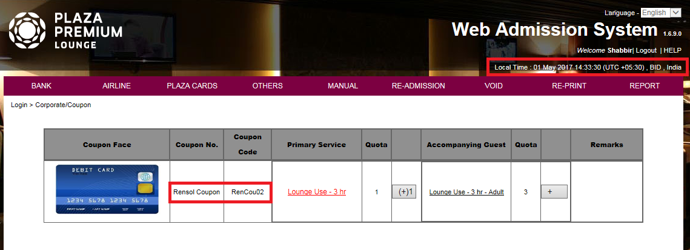
App_TC_07_05: To ensure that if we fill redeemed coupon no. then proper validation message displayed:
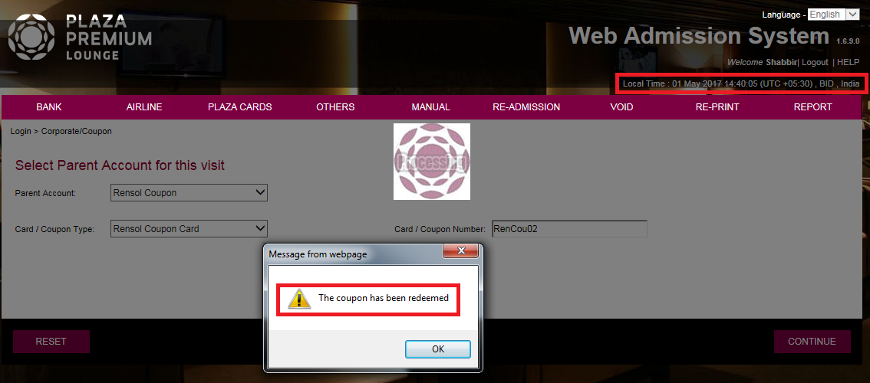
App_TC_07_08: To check for accompanying guest, quota limit displayed that we have set in BOS:
Set quota limit for accompanying guest in BOS:
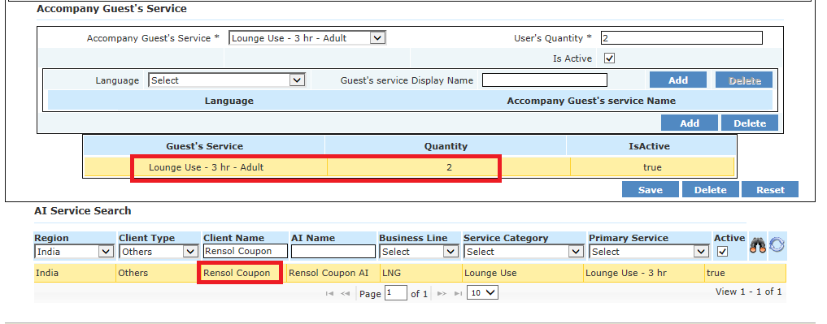
Accompanying guest quota displayed properly on ‘Admission Instruction’ screen of WAS-Client:
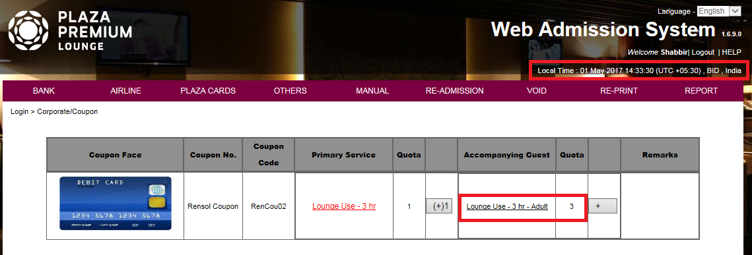
App_TC_07_10: Fill manually Name and AI code and proceed by click on "OK" of boarding pass scan form:
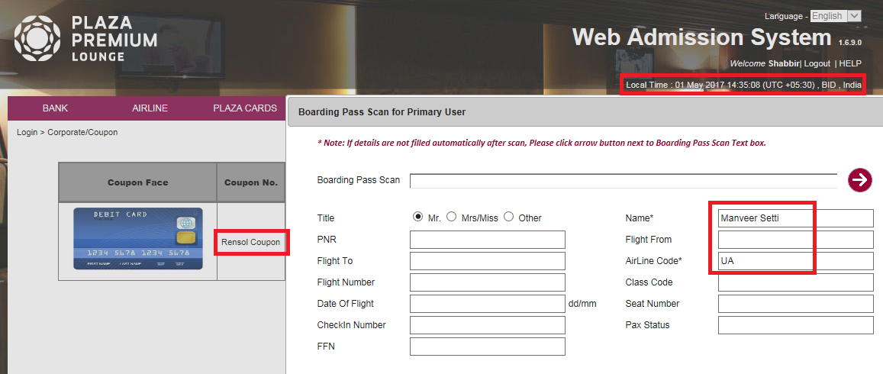

App_TC_07_11: Fill the name and complete the transaction by click on "Save" button:
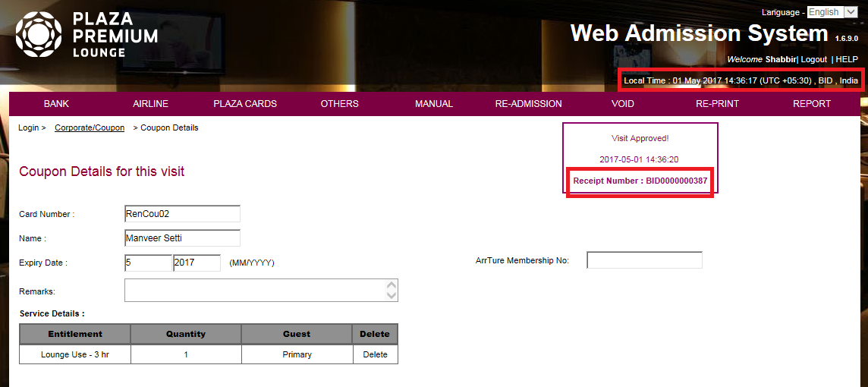

App_TC_07_14: To ensure that if we click on "Search" button without selecting any value in "Client Type" and "Receipt No." fields of Re-print screen then the previous transaction record should be displayed:
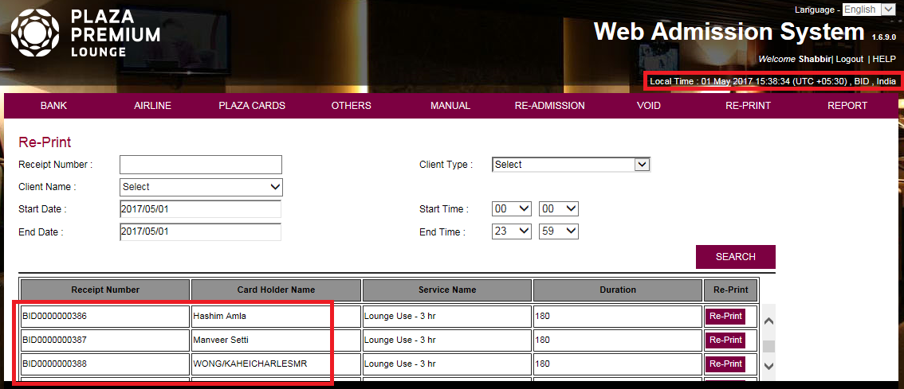

App_TC_07_16: To ensure that if we click on "Search" button by passing "Receipt No" then previous coupon transaction record should be displayed:
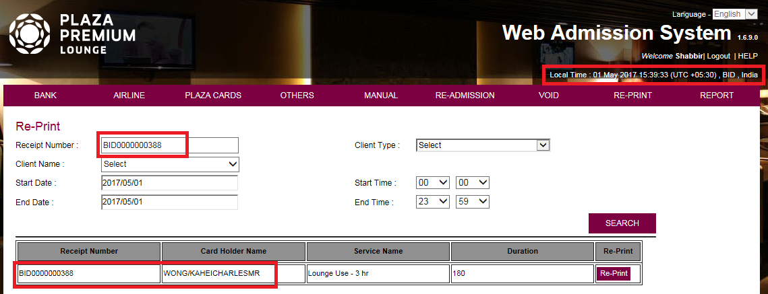

App_TC_07_18: To ensure that all the details displayed correctly on receipt that generated by re-print:
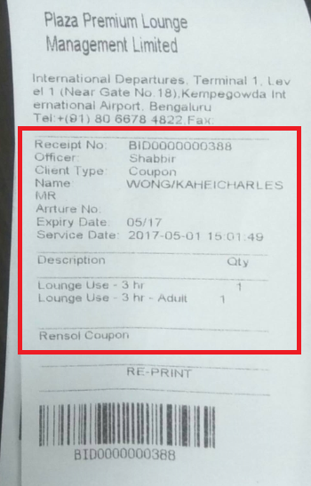
App_TC_07_19: To ensure that, current coupon transactions record should be found in "Daily Activity Summary" report:
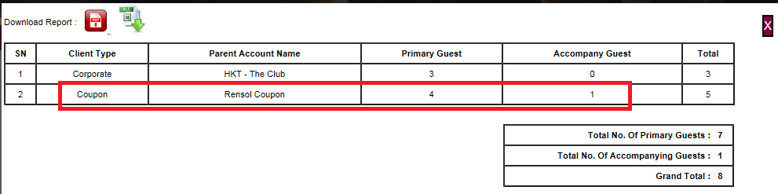

App_TC_07_20: To ensure that, current coupon transaction record should be found in "Activity Report By Boarding Pass":
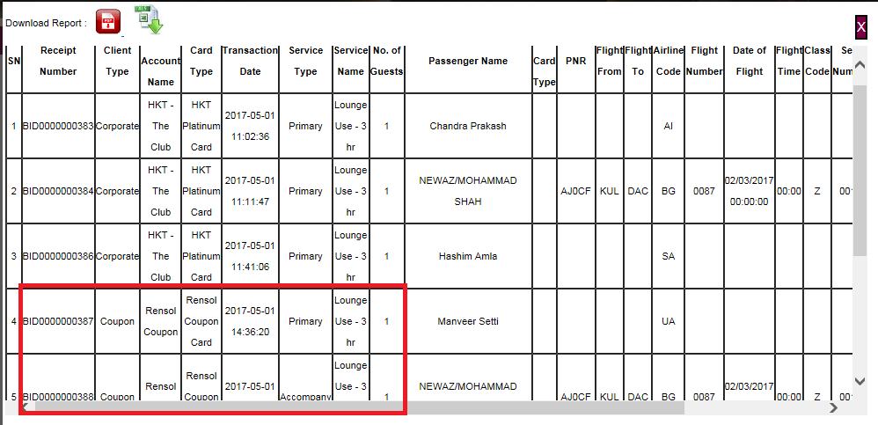

App_TC_07_21: To ensure that, we can check "Activity Report By Boarding Pass" on the basis of 'Client Type' and 'Parent Account Name':
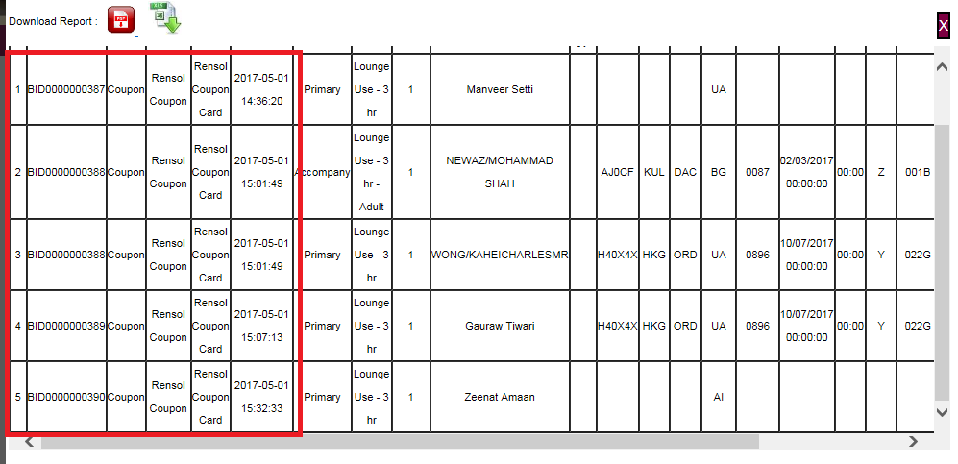
App_TC_07_22: To ensure that, current coupon transaction record should be found in "Activity Report By Cards":
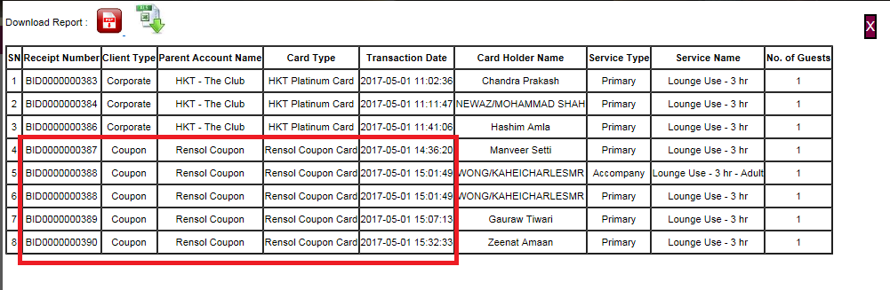
App_TC_07_23: To ensure that current coupon transaction should be displayed in "Void Receipt" form by selecting "Date" as search by:
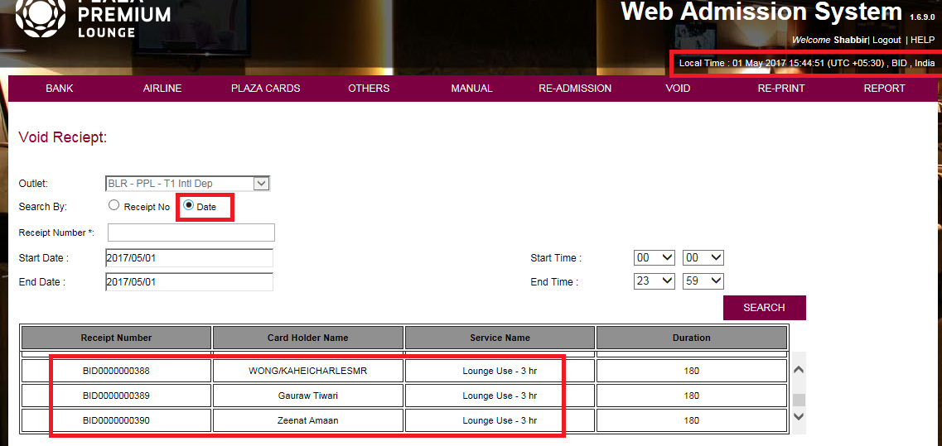

App_TC_07_24: To ensure that current coupon transaction should be displayed in "Void Receipt" form by selecting "Receipt No." as search by and passing receipt no.:
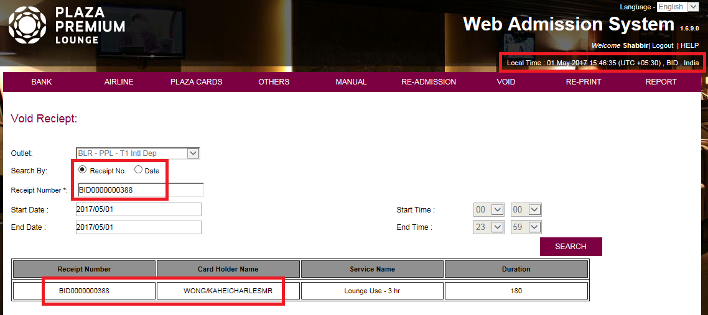

App_TC_07_25: To ensure that we are able to void ‘Corporate’ transaction by passing valid reason:
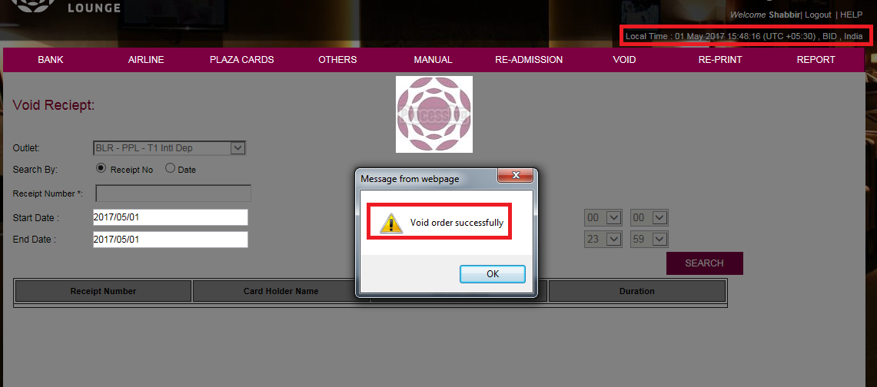

App_TC_07_26: To ensure that voided transaction should be found in “Void Transaction” report:
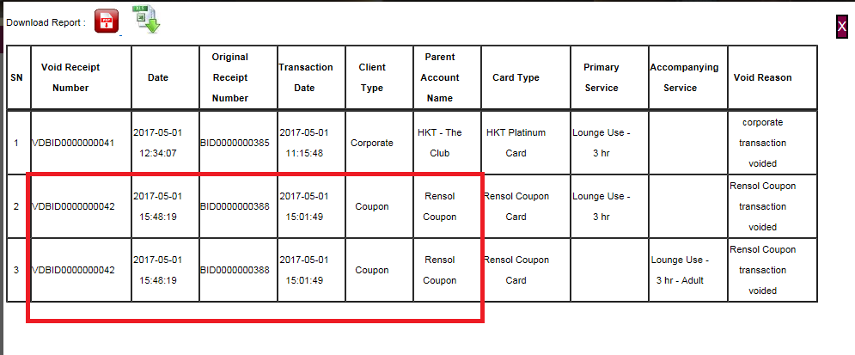

App_TC_07_27: To update the card type details and add card image in BOS and check card image appears on corporate/coupon screen of WAS-Client:
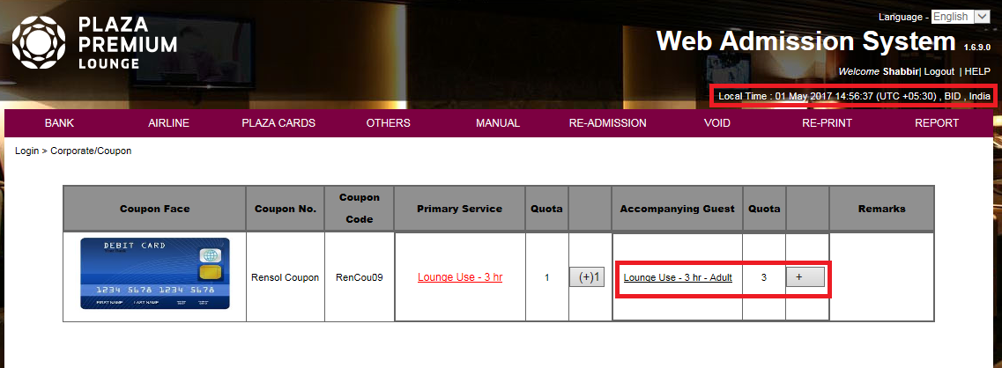
App_TC_07_28: To increase the quota limit for accompanying guest in BOS and check available quota displayed in WAS-client:
Before update, the available quota limit for accompanying guest in WAS-BOS:
After update, the available quota limit for accompanying guest in WAS-BOS:
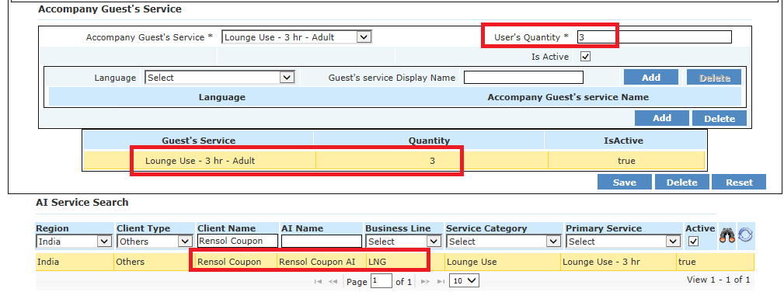
Updated quota limit is displaying for accompanying guest at WAS-Client:

App_TC_07_29: Sometimes we got an unexpected error after filling coupon no.:

App_TC_07_31: To complete one coupon transaction for 1 primary and 1 accompanying guest by using BP Scanner:
BP Scan form for Primary Guest:
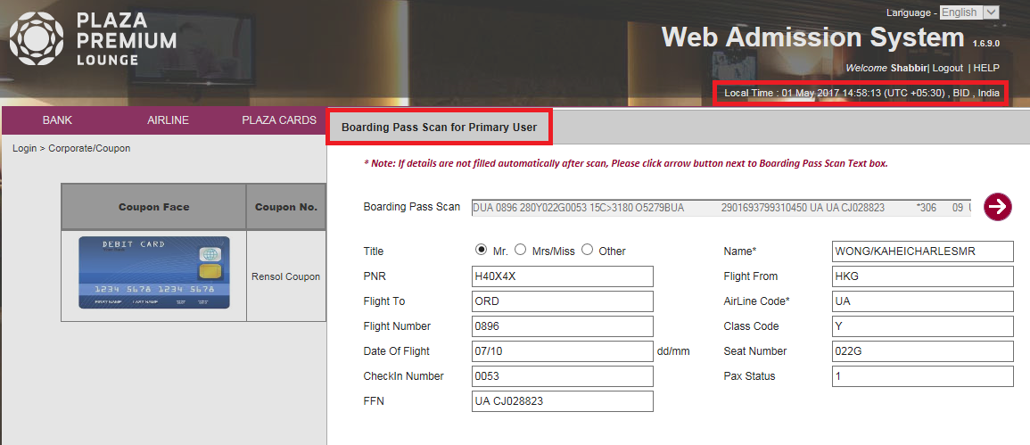

BP Scan Form for accompanying guest:
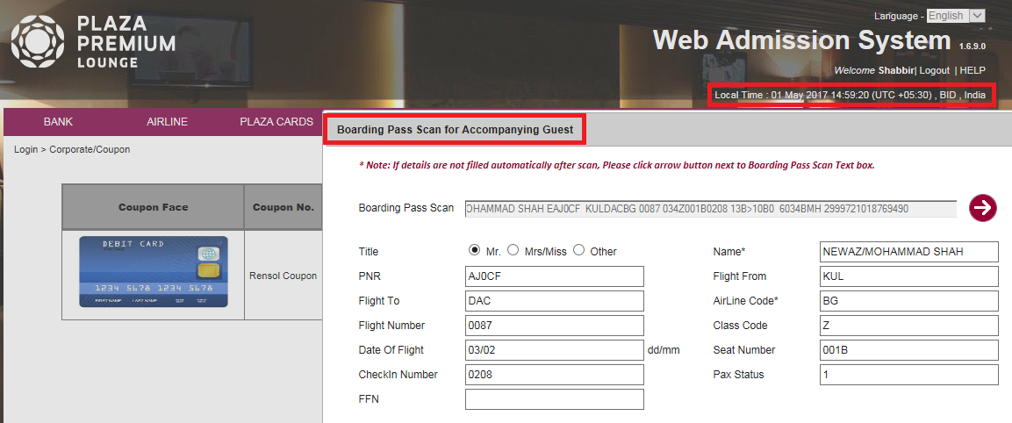

Transaction Completed Successfully:
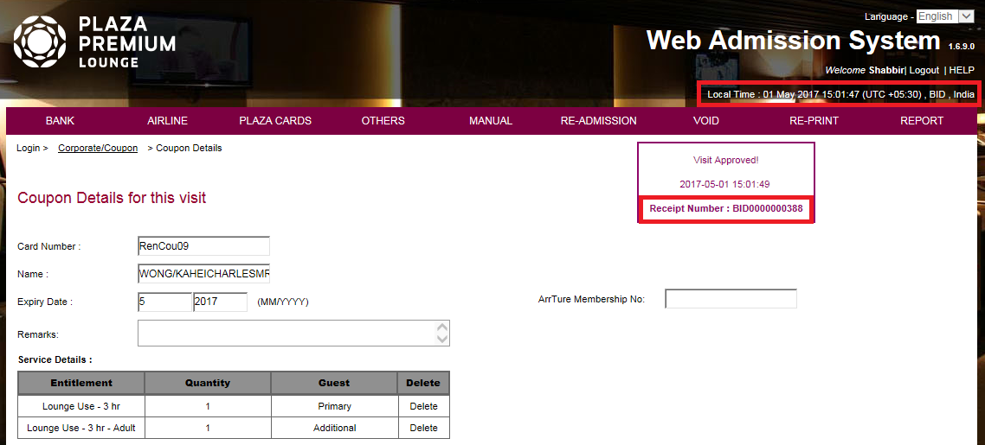
App_TC_07_32: To check, we are able to do more than 1 Coupon transaction by using same ‘Coupon No.’:
We did a coupon transaction by using coupon no. ‘RenCou18’ and ‘BID0000000389’receipt no generated:
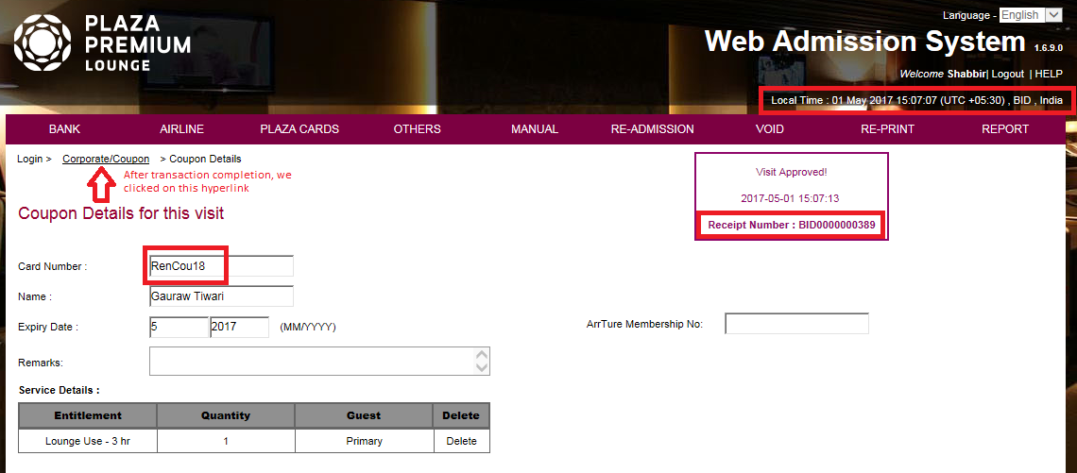

After transaction completion on ‘Coupon Details’ screen, we click on ‘Corporate/Coupon’ hyperlink from the breadcrumb and breadcrumb link redirect to Admission Instruction screen:
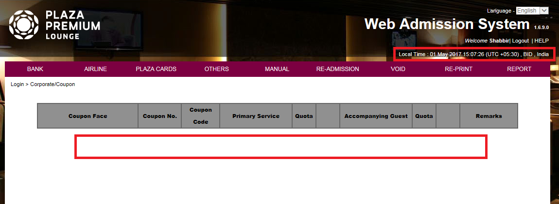

App_TC_07_33: To complete a Coupon transaction when roton device is connected and check receipt is generated with proper details:
Scan Boarding Pass for Primary guest by using BP Scanner:
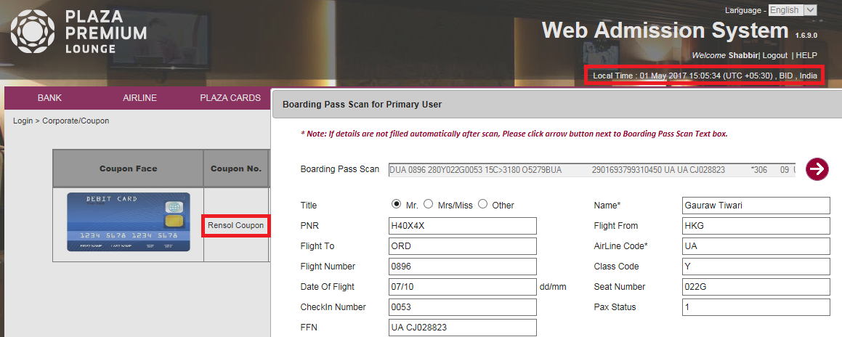

Transaction completed successfully:
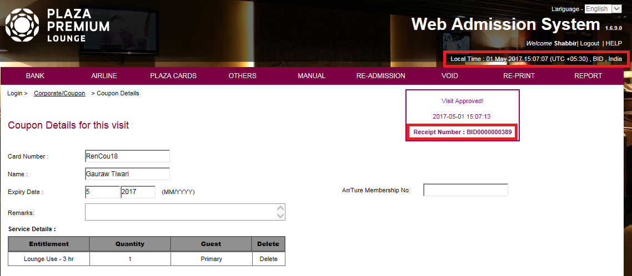
Receipt generated:
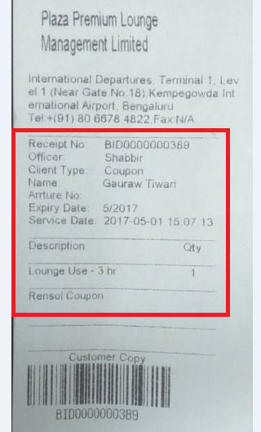

App_TC_07_34: To ensure that when validity of AI has been expired then proper validation message should be displayed:
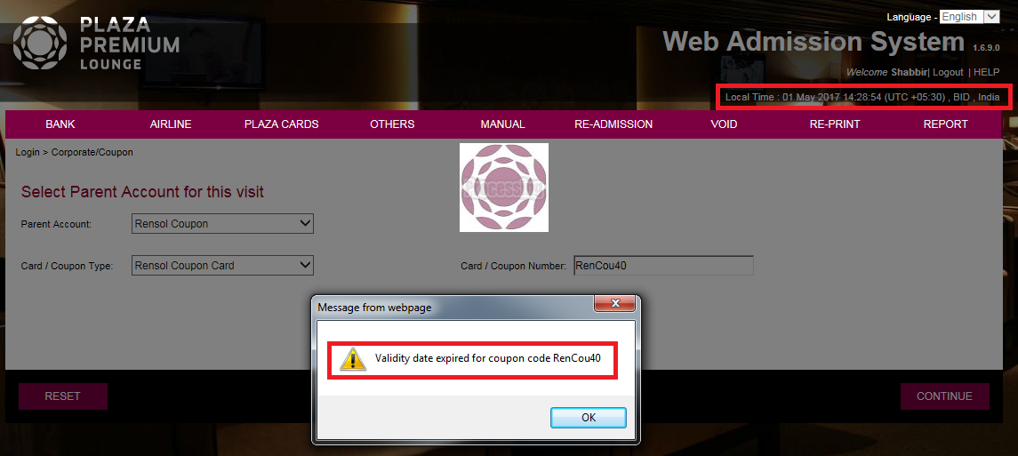

App_TC_07_36: To ensure that once GSO saved the transaction and before appearing receipt no. on screen if GSO refresh the page then system will show the receipt of previous transaction instead of new transaction:
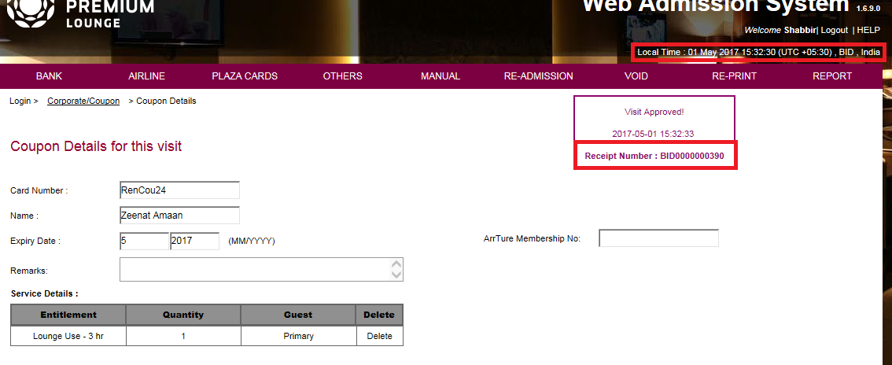

App_TC_07_37: To ensure that there is no duplicate record displayed in 'Activity Reports By Cards' report after refreshing the page at the time of transaction saving:

App_TC_07_38: When Roton device is not connected with system then on click of Re-Print button proper notification message should be displayed:
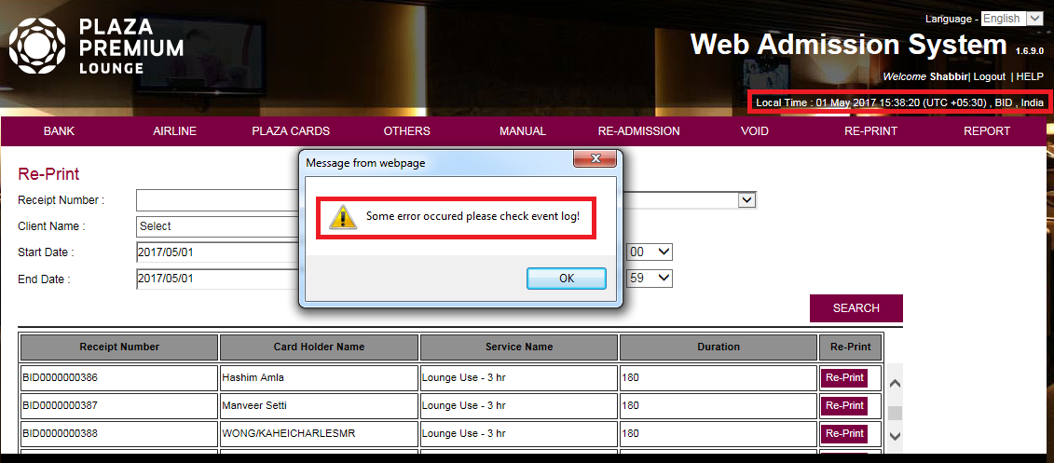

App_TC_07_39: To ensure that we can generate more than one series of Coupon for a particular Client and complete two coupon transaction by using two different series coupon numbers:
Complete a Coupon transaction by using “RenCou30” coupon no.:
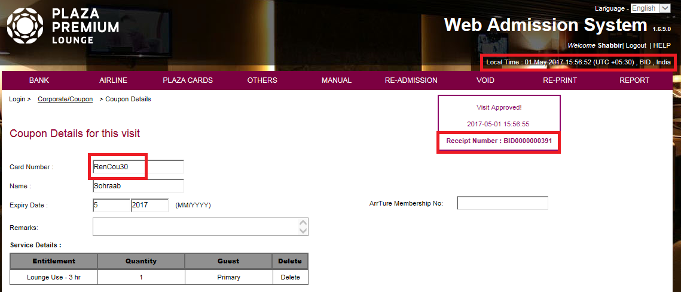

Complete a Coupon transaction by using “RC10” coupon no.:
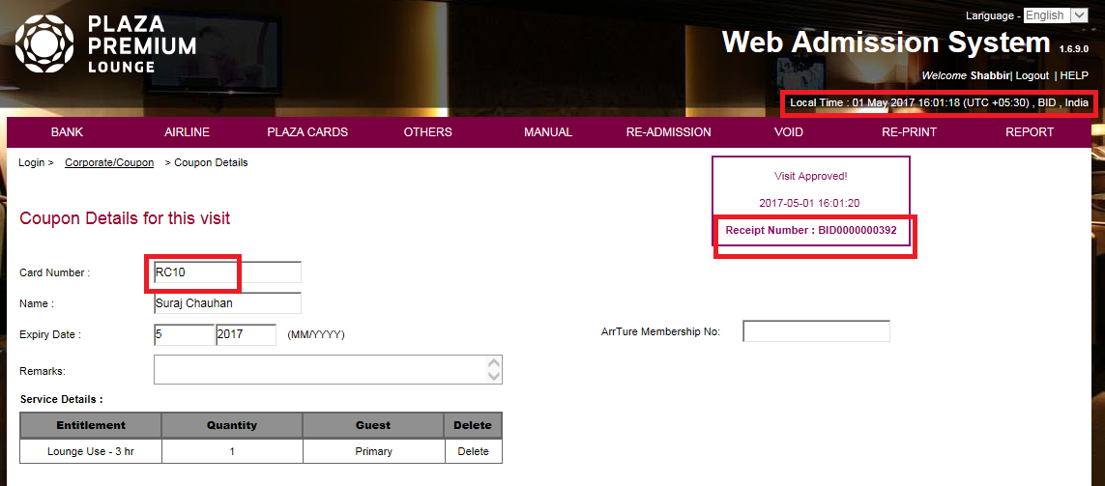

App_TC_07_40: To ensure that the voided transaction coupon no. should be displayed as "Not Redeemed" on Coupon screen of WASBOS, when we have saved coupon transaction using not redeemed coupon and voided the same transaction:
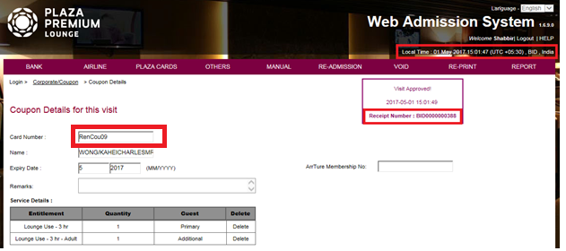
Coupon no. “RenCou09” displayed as 'Not Redeemed’ in BOS:
